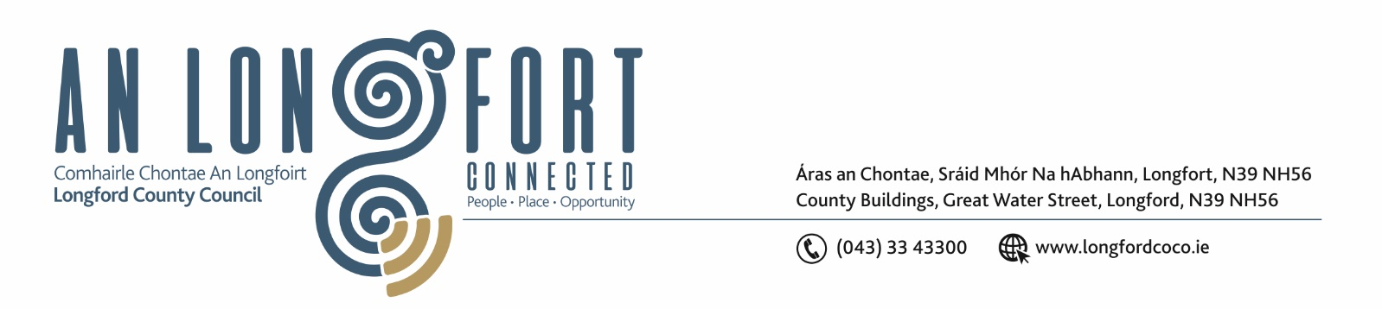

Please Note Venue for Meeting – Longford Rugby Club.

2u Iuil 2020.

Chuig: Gach Ball don Chomhairle.

A Chomhairleoir,

Iarrtar ort bheith i láthair ag Cruinniú Chomhairle Chontae Longfoirt a tionólfar i
Club Rugbaí Longfort ar an Chéadaoin, 8u Iuil 2020 ag 3.00 p.m chun gnó a dhéanamh d’réir an Chláir thíos.

You are requested to attend Meeting of Longford County Council to be held in
Longford Rugby Club, Demesne, Longford on Wednesday, 8th July 2020 at 3.00 p.m. to transact business, as set out on the Agenda hereunder.
.

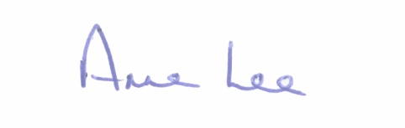
Mise le meas,

__________________
Anne Lee,
Meetings Administrator.

C L A R

- Confirmation of Minutes of Longford County Council meeting held on the
20th May 2020 - copy enclosed.

- Matters arising from Minutes.

- Declaration of Interest by Members.

- To note Chief Executive Report - to follow.

5. To note adopted Minutes of Corporate Policy Group Meeting held on
8th April and 20th May 2020 - enclosed.

6. Strategic Infrastructure and Climate Change.

- To note Planning Applications received since last meeting of the Council.

- Consideration of the disposal of Freehold Interest of 15, Harbour Row,
Longford Town in accordance with the terms of Section 183 of the Local Government Act 2001 issued on the 8th June 2020.

- Consideration of Adoption of Part 8 Report (Planning and Development Act 2000 (as amended) and Planning and Development Regulations 2001) (as amended) in respect of the construction of an access road at N4 Cooleeny (Shroid), Co. Longford - details attached.

- Consideration of Adoption of Part 8 Report (Planning and Development Act 2000 (as amended) and Planning and Development Regulations 2001) (as amended) in respect Cnoc Mhuire Bus Parking Facility at Granard,
Co. Longford - details attached.

- Consideration of Adoption of Part 8 Report (Planning and Development Act 2000 (as amended) and Planning and Development Regulations 2001) (as amended) in respect proposed Off Street Car Park at Main Street, Ballymahon
Co. Longford - details attached.

- Notice of Motion submitted by Councillors, as listed hereunder –

Councillor Uruemu Adejinmi.

“According to the 2016 Census (Profile 6 – Commuting in Ireland), 56,837 people cycled to work (an increase of 43% since 2011) of which two thirds of all cyclists were in Dublin city and suburbs with 38,870 people cycling to work; 2,330 people cycled to work in Cork city and suburbs; 1,874 in Galway; 968 in Limerick; and 395 in Waterford. This is an indication of the emerging trend to cycling in both the Capital and the Country.
A recent report by Vera O’Riordan and Hannah Daly of the Environmental Research Institute showed a drop in car travel by around three-quarters as a result of the lockdown which is significant considering that Transport accounts for about 40% of Ireland’s energy-related CO2 emissions. A significant number of people, especially families and young people, took to walking and cycling during the pandemic.
I call on the County Council to apply for National funding out of the transport capital budget for cycling projects and commence plans to deliver a network of cycling routes in the County, develop cycling infrastructure (cycle lanes, bicycle parking facilities, traffic signage, etc.) and implement bicycle-friendly measures (bike-to-rent schemes, designate safe places for people to learn to cycle) to enhance public transport and boost tourism. Cycle lanes can also be designed for wheelchair users (Case study: Seville, Spain)”

Councillor Gerard Farrell.
“That Longford County Council considers that a new Litter Programme for outdoor recreation areas, as this is becoming a serious problem across the County.”

Councillor Turlough McGovern.

“I call on Longford County Council to oppose the planning for Industrial Wind Turbine by Kiernan Milling - PL20105 - citing its negative impact on the following -
Environment : wildlife and scenic visual value, impact on ground water.
Residential : value and landscape of homes, noise impact and health implications on the residents of Granardkille, assessments are not concluded (no noise survey carried out) and citing inadequate consultation with the residents and public in that area.”

7. Finance and Regeneration.

- Notice of Motion submitted by Councillor Turlough McGovern.

“That Longford County Council abolishes Commercial Rates for the rest of 2020 due to Covid 19, to help alleviate financial pressure on struggling businesses to stay open.”

8. Community, Corporate and Enterprise.

- NOAC Circular 01/2020 – Review of Corporate Plan 2015-2019 –
documentation enclosed.

- Filling of vacancies on Committees following the election of Micheál Carrigy
to Seanad Éireann.

- Consideration of dates, times and locations for Council and Corporate Policy
Group Meetings.

- Notice of Motion submitted by Councillors, as listed hereunder –
Councillors Uruemu Adejinmi, Seamus Butler, Mick Cahill,
Martin Monaghan, Pat O’Toole and PJ Reilly

“We call on the County Council to seek National and EU Funding (SFI; Horizon 2020; Horizon Europe 2021-2027; etc) for a Specialist Research & Innovation Institute to be located in the Longford Army Barracks building.
We want Longford to be a Centre of Excellence (COE) in Research and Innovation across the arts, humanities, social sciences, and STEM.

This motion aligns with National priorities in relation to equity of access to Higher Education, research-informed teaching, and learning excellence. It also supports enterprise and regional development and will foster a culture of lifelong learning within the workforce in and around Longford. It will also support the Just Transition initiatives in the midlands.”

9. General.
- Correspondence – circulated
- Letter dated 24th June 2020 received from the Office of the Minister for Housing, Planning and Local Government regarding the electoral registration process.

- Notices of Motions, submitted by Councillors, as listed hereunder -
Councillor Gerard Farrell.
“That this Council writes to ESB to ask that the Company to hold off on any demolition of the Power Station in Lanesboro to allow for feasibility work to be done on potential replacements within the structure.”

10. Votes of sympathy.



